NAGARAJ NAIK

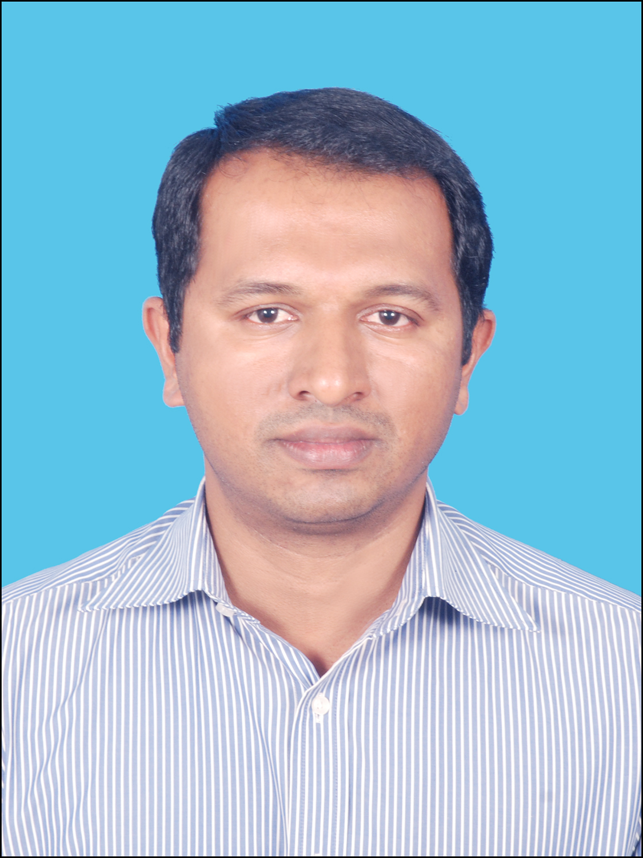

Total Experience:
20 Years

Permanent Address:
S/o Madev Naik, Melin Mane, PO: Chitrapur, TQ: Bhatkal,
Dist: Uttar Kannada – 581 354

Present Address:
C/o Anant Gopal Naik ,

Near Primary School No. 4.
Kumta Road, Nilekani, Sirsi,
Karnataka.581401

Mobile:
+91 – 9099055297

E-mail Id:
nraj1277@gmail.com
nagaraj.naik@yahoo.co.in

Passport No. P0141104

OBJECTIVE:
To contribute effectively at a senior management level in corporate setup by leveraging the experience and skill sets gained over the years.

SUMMARY: A senior Sales, Marketing and Business Development professional with 20+ years of experience in the automobile sector.

EDUCATIONAL QUALIFICATION:

Diploma in Automobile Engineering from SV Polytechnic, Kumta, Board of Technical Education, Bangalore

CORE COMPETENCIES:

- Channel Sales
- Achieving sales Target
- Revenue generation through tie-ups and cross-promos
- Training, Teaching and Manpower development
- Process Development and Systems creation for standardized formulation and effective implementation
- Key Account Management
- Customer Relationship Management – Customer Loyalty Programs, handling of Customer Complaints and Customer Grievances Redress
- Brand Management–Brand Identity, Brand Positioning, Brand building.
- Marketing Communication–Advertising, Sales Promotion, Direct Marketing and Events
- Market Research – consumer research

BUSINESS AREA:
Sales & Marketing / Business Development

TARGETED POSITION & INDUSTRIES:
Senior management position in a professionally managed multinational organisation

HIGHLIGHT OF EXPERIENCE:
- A dynamic professional with over 20+ years of rich experience in managing the sales and marketing functions with focus on revenue growth and profit maximization of the organization.
- Shared vision of the Business and Organization, formulating business strategies for strategic utilisation and deployment of available resources to achieve organisational objectives.
- Devising short term and long-term goals for achieving top line and bottom-line profitability.
- Overseeing Marketing and Sales operations and implementation for achieving effective and increased growth & profitability. Ensuring maximum brand visibility and capturing optimal market share.
- Formulating Annual Marketing Plans, Budgets and Calendars for accomplishment of assigned targets.
- Formulation and implementation of Customer acquisition and customer retention strategies.
- Devising & effecting competitive promotional and sales programs/strategies to improve the product and brand awareness.
- Setting performance standards and measuring performance for efficient delivery in the sales and marketing domains.
- Coordinating visual merchandising activities like: window display in tune with market demands, thematic in store displays and effective visual impact for higher sales conversion.
- Providing effective leadership and direction to the sales and marketing personnel to ensure that members are motivated. Devising methods to improve performance of staff.
- Motivating, mentoring, guiding and monitoring executives to achieve goals.
- Interfacing with customers to understand their requirements, co-ordinating with the technical / merchandising teams & devising optimal solutions to satisfy customer’s needs.
- Collating accurate feedback from clients through scientific customer research to identify areas of improvement in the service levels.
- Conceptualizing & implementing Public Relations & Corporate Communication strategies for product lines, corporate image etc. to build credibility, trust and goodwill for the company and its brands
- Setting up communication channels / press conferences with media majors, for successful media penetration & coverage.
- Managing customer centric operations & ensuring customer satisfaction by achieving delivery & service quality norms.
- Attending to clients (individuals / corporate clients) concerns & complaints and undertaking steps for effectively resolving them.

PROFESSIONAL EXPERIENCE

Employer: TAFE Ltd: Karnataka Tamilnadu Since Sep 2019 to Till date

Dealer Development Manager reporting to GM

Responsibilities:
- Identifying and networking with prospective clients generating business from existing accounts and achieving profitability as well as increased sales growth
- Leading the development and implementation of annual sales plans that resulted in consistent sales increase; achieving sales growth that consistently outperformed key competitors and the industry as a whole
- Developing and appointing new business partners to expand product reach in the market and working in close interaction with the dealers and distributors to assist them to promote the product
- Utilizing resources and marketing tools to establish new dealer thereby achieving preset targets; engaging in relationship building, customer retention, new customer development, maximizing revenue, and up-selling
- Leading the development and implementation of annual sales plans to all new dealerships that resulted in consistent sales increase; achieving sales growth that consistently outperformed key competitors and the industry as a whole
- Managing customer centric operations and ensuring customer satisfaction by achieving delivery timelines and service quality norms
- Monitoring financial regularities of dealers of the region

Employer: TAFE Ltd: Maharashtra Pune Since Sep 2016 to Aug 2019

Area Manager (Implements) reporting to GM

Responsibilities:

- Responsible for Sales Volume/Market share Implement product line of Maharashtra annually.
- Responsible for attachment ratio Improvement
- Responsible for Subsidy business volume and Market share
- Responsible for BTL activity and generation of enquiry.
- Monitoring financial regularities of dealers and retail tracking
- Setting up monthly sales promo or incentive to a set of dealers
- Motivating, mentoring, guiding and monitoring executives to achieve goal
- Setting performance standards and measuring performance for efficient delivery in the sales domains.

Employer: Mahindra and Mahindra Ltd Rajkot since Apr 2014 to Sep 2016

Senior Territory Business Manager reporting to DGM

Responsibilities:
- Responsible for Sales and Service Volume/Market share at set of Dealership for monthly and annually.
- Setting up monthly target for dealer and Planning of Yearly Volume and Market share
- Manpower appointment of dealers, Training of manpower Technical, commercial and event management & enquire generation.
- Monitoring financial regularities of dealers and after sales service monitoring.
Customer Relationship Management – Customer Loyalty Programs, handling of Customer Complaints.
Planning of event, activity, ads on monthly and quarterly basis for the set of dealers in Sourastra.
- Responsible for addressing customer’s grievance at the field level
- Setting performance standards and measuring performance for efficient delivery in the sales and Service domains.
- Motivating, mentoring, guiding and monitoring executives to achieve goal

Employer: Mahindra & Mahindra Ltd: Gujarat Ahmedabad Since Apr 2013 to Mar 2014

Senior Territory Manager reporting to Sr. Area Manager

Responsibilities:
- Responsible for Sales Volume/Market share at set of Dealership for monthly and annually.
- Setting up monthly target for dealer and Planning of Yearly Volume and Market share
- Manpower appointment of dealers, Training of manpower Technical, commercial and event management & enquire generation.
- Monitoring financial regularities of dealers and after sales service monitoring.
Customer Relationship Management – Customer Loyalty Programs, handling of Customer Complaints.
Planning of event activity, ads on monthly and quarterly basis for the set of dealers in North Gujarat.
- Setting performance standards and measuring performance for efficient delivery in the sales domains.
- Motivating, mentoring, guiding and monitoring executives to achieve goals

Employer: Mahindra & Mahindra Ltd: Karnataka Duration: Feb 2011 to Mar 2013

Senior Territory Manager (Mahindra Viswas) reporting to Deputy General Manager

Responsibilities:
- Responsible for infrastructure development per company norms, developing exchange organization in all dealers across Karnataka.
- Manpower appointment of dealers, training of manpower technical /commercial and setting up monthly target for dealers, event management & enquire generation.
- Monitoring financial regularities of dealers and after sales service monitoring.
- Planning of event, activity, ads on monthly basis. Managing the dealer appointment, activation and inauguration, day today business planning for dealer and to company across entire Karnataka for Pre-owned tractors business.
Employer: Advaith Motors Pvt. Ltd., Bangalore Duration: July 2009 – January 2011

Senior Manager – Operations reporting to GM – Sales & Marketing

Responsibilities:
- Responsible for quality procurement, timely refurbishment on cars procured, made sure all subordinates get adequate training / facility / promotion.
- Managed entire operations of Advaith Hyundai Advantage-POC division. Handled team of sourcing, refurbishment, sales, finance and accounts. GDMS system Management as per HMIL advantage policy and procedures.
- Facilitated Setting up of the target in accordance to the HMIL-POC for achieving these goals on a month basis.
- Ensured that the increase in percentage of exchange along with managing Hyundai Advantage operations of dealer branches in Mysore and Mangalore.

Achievements:
- Raised the sales and procurement volume to 3 times original, HMIL certificate volume to 53%.
- Initiated “POC Auction / Buyers & Sellers Meet” first of its kind, which is done at Advaith Mysore branch on July 25th 2010 in association with Hyundai Advantage -POC and radio partner Big FM 92.7.
- Adroitly auctioned 8 cars and followed that Aug 1st 2010 at Advaith Bangalore, made huge success by auctioned 22 cars in a day. “It is well appreciated by HMIL”.
Employer: Auto 1 Motors Pvt. Ltd., Bangalore Duration: December 2008 – May 2009

Senior Manager reporting to General Manager

Responsibilities:
- Ensured every vehicle procured right product mix, right quality and the right refurb cost.
- Conducted a meeting with the repossession in-charge of the finance companies, negotiate with them for pricing and workout comprehensive package for the procurement of the cars at one stretch.
- Deftly conducted Induction Training Program for new employees – Educating them on the complete cycle of Business Process.
Employer: Mahindra First Choice, Bangalore Duration: September 2003 – November 2008

Manager Procurement reporting to Deputy General Manager

Responsibilities:
- Tracking market on day today bases for pricing & increasing profitability of firm.
- Finalized and established tie-up’s with:
  - The finance DSA’s under the “Buying House” concept.
  - The corporate sectors for selling & buying of pre-owned cars.
- Met repossession in-charge of the finance companies along with negotiating with them for pricing and workout comprehensive package for the procurement of the cars at one stretch.
- Developed relationships with new car dealers for buying house concept, helping them in their exchange schemes and at the same time getting more procurement.

Achievements:
- Adroitly executed projects 110 and achieved 110 cars in the month of March 2006.
- Efficiently executed the project through corporate events, road shows and through promotions.
- Stellar in corporate tie ups with companies such as Wipro Bangalore, HP, IBM, Infosys, I Gate, Target India, Essae teraoka, Lease Plan, Metro cash and carry, ALD automotives and many more.
Employer: Sai Automobile Sales & Service Ltd., Mumbai Duration: July 1999 – July 2003

Service Adviser reporting to Works Manager

Responsibilities:
- Efficiently interacting with customer complaints and making job cards. Deftly led the team of Technicians and giving instructions along with conducting pre-delivery inspection.
- Spare parts follow up with spare part division and with company. Mechanics are given adequate training timely bases. Mechanics target reached/incentive they get on time.
- Interacting with insurance company and valuator for timely assessment of body repair and get the payment credited to firm.

Project Handled

1 RECON (14th Nov 2013 to 25th Jan 2014)

Issues phased: Liquidation issues across Zone 1.

Selected 14 Dealers who are main contributor to the volume and market Share.
By visiting dealers, I found out that Tractors where dumped in stock yard. Not in starting condition so I have advised them recondition tractor n do proper display in front show room. We have selected in each dealer 5 tractors and second hand parts procured from Gray market where cost has come down drastically..

We are able reduce ageing days by 4 to 5 months to within 30 days (on an average) and able to see profit on old tractors sells.

After seeing the success all the dealers are adopted process and 112 tractors liquidated through this process.

2 INSTITUTIONAL SALES (20TH May 2014 to 31st Jul 2014).

Mini Tractor Yojana (GR of Social Justice and welfare Ministry Gov. of Maharashtra)

I was handling Satara, Kolhapur and Sangli dist. of western Maharashtra.

Delivered 122 tractors with Trailer and Rotavator to SH Group.

SPECIAL AWARD

F16 Best Territory Manager category
Runner up Zone 1

